Software Report:

Installing OpenCV:

OpenCV was an essential part of our project and so we will first cover how to set it up on your machine.

Windows (and Visual Studio 2013):

- Download the latest version of OpenCV (we used 3.0.0) and extract it to “C:/”.
- Right click on My Computer and go to properties.
  - Click Advanced System Settings
  - Click Environment Variables
  - Click New and set OPENCV_DIR against the variable name and C:\opencv\build\ against the variable name.
  - Click Path followed by Edit
  - Follow the instructions on the following blog:
http://opencv-srf.blogspot.com/2013/05/installing-configuring-opencv-with-vs.html

NOTE: We found Visual Studio to be troublesome so we stuck to XCode.

Mac OS (and XCode):

- Follow the following video to install OpenCV:
https://www.youtube.com/watch?v=U49CVY8yOxw&feature=youtu.be
- Follow the following video to configure OpenCV with XCode:
https://www.youtube.com/watch?v=XJeP1juuHHY
NOTE: You will need to configure every XCode project you by following step 2 if you want it to work with OpenCV.
- In XCode, you need to specify the folder that contains helper files.
  - Click on Product in the tool bar and then click Edit Scheme.
  - Check the Use Custom Directory check box.
  - Add the path to the folder you want to use.
This is where all the images/videos will be saved and accessed from.

LINUX (Ubuntu 14.04):

This was the operating system we used for the Jetson TKI. OpenCV was installed during the initial flashing on the OS.
NOTE: We this was OpenCV 2.4.8 and some functions differ from 3.0.0.

NOTE: To learn more about OpenCV, use the following link:
http://opencv-srf.blogspot.com/2010/09/opencv-basics.html

The Relevant Files and Folders (Algorithm):

The Bike Detector 3.0 folder contains all the files and folder relevant to running the bike detection program. (Some of them are in a different folder and so not seen in the picture below)

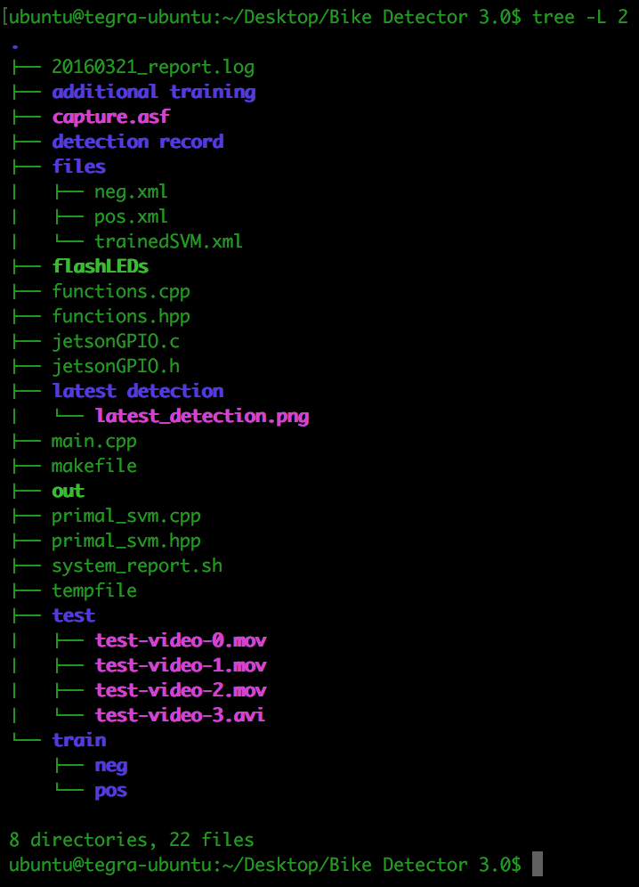

There are a total of 14 files. Their names and purposes are given below.
NOTE: We omitted the test videos due to space restrictions of Github.

20160321_report.log:

This file is generated by a Bash Script to give a short description about the system. The file name reports the date on which the report was logged, this was logged on March 21st 2016.

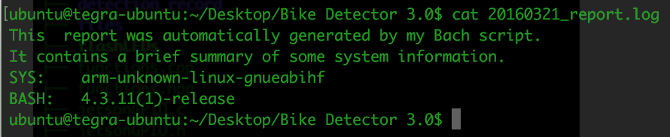

It describes the version of Linux the Jetson is using, arm-unknown-linux-gnueabihf, and the version of Bash installed, 4.3.11(1).

flashLEDs:

This is an executable file that uses methods declared in JetsonGPIO.h to flash the lights of the alert sign on and off. In order to flash the lights, this code is actually flipping the output value of GPIO pin57 in the Jetson TK1. The flashing occurs for a total period of 3 seconds, having the LEDs be on in intervals of 0.5 seconds.

functions.cpp and functions.hpp:

These files contain all the functions used for the bike detection program. The function setup takes the command like arguments as its parameters and parses them to check what flags the user has entered. It also edits the values of the state variables of the stateFlags struct. The printHelp function just prints out the flags that can be used with the program. The function extractFeatures, takes as its argument a folder name and the number of files in the folder. The trainSVM function uses the neg,xml and pos.xml files in the files folder to construct an SVM. The performanceTest function is used to evaluate the detection accuracy of an SVM. Finally, the findBikes function runs the detection program on a camera feed or a video. The cameraTest function is used testing if the camera is functioning and also to get the dimensions for the region of interest of detection.

ina219.cpp and ina219.h: (In SensorFiles folder)

These files have the functions to interact with the INA219 current sensor. They were obtained from a public repository:
https://github.com/adafruit/Adafruit_INA219

ina219-read.cpp: (In SensorFiles folder)
This program interacts with the INA219 current sensor connected to the Jetson using I2C protocol. It reads the battery’s current and voltage levels and uploads the information onto the RightAlert website. The methods used in this program are from the ina219.h file. The original file was obtained from the same online repository as the ina219.cpp and ina219.h files. Edits were made to it to allow for website communication.

JetsonGPIO.c and JetsonGPIO.h:

These files have methods that make it incredibly easy to interact with the Jetson’s GPIO in a C or C++ program. They were obtained from a public online repository at:
https://github.com/jetsonhacks/jetsonGPIO
This library file contains methods to export, unexport, set direction, and set values of GPIO pins. These were used to create the “flashLEDs” executable, which was run in the final detection algorithm.

main.cpp:

This file contains the main function for the program. It takes in the command line arguments and calls the setup function to setup the flags and then base on the flags it decrypts what the user wants. This is the file that contains the variables for the region of interest for detection that need to be changed when first setting up the system.

makefile:

This is the makefile used to compile the program. It is a quick and east way to compile all the files, by just typing make. It removes the need for remembering all the compilation flags.

out:

This is the executable file for the detection program. You can run by entering ./out in the terminal. You can also add certain flags as command line arguments. These are discussed in more detail in the next section.

primal_svm.cpp and primal_svm.hpp:

These files describe the PrimalSVM class which inherits from OpenCV’s CvSVM class. The class provides helpful functions to help interface between the SVM and the hogDescriptor methods.

system_report.sh:

This is a bash script to log a report for the system. It can be run by entering system_report.sh in the terminal.

There are 5 folders. Their names and purposes are as follows.

additional training:

This folder is a container for any images that need to be added to the training folder for the SVM.

detection record:

This folder contains images of the recent detections. These images allow us to debug the application and improve the SVM.

files:

This folder contains the xml files generated when extracting features and creating an SVM. The pos.xml file contains the features of the positive training images while the neg.xml file contains the features of the negative training images. The trainedSVM.xml file contains the trained SVM itself.

latest detection:

This folder only contains a single image called latest_detection.png. It is updated with the image of the latest detection made.

test:

This folder contains the test videos and positive and negative image for testing.

train:

This folder contains the positive and negative images for training.

Running The Program:

The detection program can be run in a number of ways. The out file is the executable. Running ./out in the terminal should give you a help message. There are several flags that can be used with the program.

--debug: Enable debug mode with provides some output statements and a visual record of the detection.
-- train: Uses the positive and negative training images in the train folder to train the SVM. The user is prompted to enter the number of positive and negative images.
--performanceTest: Uses the trained SVM to run detection on positive and negative images in the test folder. It then computes important performance related data like the confusion matrix and the true positive rate and false positive rate.
--detection: Starts the detection algorithm on a specified video or a camera feed.
--video <filename>: Specifies the video file to run the detection algorithm on.
--camera <camera_id>: Specifies the camera to use for running the detection.
--cameraTest <camera_id>: Runs a video capture from the specified camera. Pressing ‘esc’ saves a snapshot of the last frame and quits the program. Moving the mouse displays the mouse coordinates in the terminal.

The makefile can be used to compile the files in the folder. Just run make in the terminal. Then run ./out with and other flags you wish to use.

Examples:

To Train: ./out --train
To Detect on a Video: ./out --detection --video test/test-video-3.avi

The variables top_left_x, top_left_y, roi_width and roi_height in file main.cpp need changes to be changed every time the system is setup at a new location. The changes are to the numbers that determine the region of interest for the detection. To reduce the impact on the computational power we focus on a specific region of the frame. Use the --cameraTest flag to view the input to the camera. Moving the mouse displays the mouse coordinates in the frame to the terminal. Find the values that best suit the detection region. Compute the width and height of this region and enter the values into the main.cpp. Type make in the terminal and hit enter. That’s it, the code is ready to start detecting at the specified region of interest. Run ./out --detection --camera 0 to start detecting.

Changing the Rate and Time Period of Flashing for the Alert Sign:

The length of time the alert sign flashes and the rate at which the LEDs flash can be altered if desired. To do this, edits to the flashLEDs.cpp file must be made. In the code there is a loop specifying the amount of time the LED should be on and off. Play with this value to alternate the rate at which the LEDs flash. Take into account that the values are in microseconds. When changes are completed, compile the program with:
g++ JetsonGPIO.c flashLEDs.cpp -o flashLEDs

The Relevant Files and Folders (System / Website):

There are multiple folders in that are used by the system for tasks such as updating the database, powering off the Jetson if the battery voltage drops below 11.1V, making sure Internet connection status remains connected, etc.

In the duckdns folder, is a script that was downloaded directly from duckdns.org. Duckdns.org is a Dynamic DNS provider. Through this script, we are able to always communicate with the Jetson when it is connected to the Internet without having the IP address visible to us first. The duck.sh script in this folder runs as a cronjob every minute.

duckdns/duck.sh:

This file is executed every minute by a cronjob. It was downloaded directly from duckdns.org after setting up ra-jetson.duckdns.org as our preferred domain name for the Jetson. The script authenticates with DuckDNS and updates the DNS record with the IP of the Jetson.

In the NetworkScripts folder, there are three scripts. Two scripts are used to ensure that the Jetson remains connected to the “Right Alert” wireless network. In the case of a disconnect, the first script will detect if there is no Internet connection. Often times, the connection was not automatically reestablished. The two network scripts in this folder run as cron jobs every minute and every five minutes respectively. This folder can be found on the Jetson in the following directory: /home/ubuntu/Desktop/bandhan/NetworkScripts

NetworkScripts/CheckAndRestartNetwork:

This script runs an nmap command every minute by a cronjob. If the nmap command fails, the network manager service is restarted, and the Jetson attempts to reconnect to the Right Alert wireless network.

NetworkScripts/NetworkFailReboot:

This script runs an nmap command every five minutes by a cronjob. This command is unlike the first command as number of tries for the nmap command is increased to twenty. This allows the first script to reestablish Internet connection before this script fails. If this script fails, the Jetson is rebooted. This was done because we observed in a couple of instances that the USB Wi-Fi dongle hardware could fail to be recognized by the Jetson. If this occurs, the only way to resolve this besides physically reconnecting the device is by rebooting the Jetson.
In the CameraScripts folder, there is a Python script that will upload the latest detected image to AWS S3. The algorithm program calls this script every time a biker is detected. Later, a biker image photo is saved. Camera scripts were originally placed in the following directory: /home/ubuntu/Desktop/bandhan/CameraScripts

CameraScripts/uploadS3.py:

This file authorizes a connection with AWS S3 and uploads the latest detected image from the Right Alert System directly to the cloud. This image is then displayed live on the administration web site.

In the SQL-Scripts folder, there are multiple scripts that are used to update the database. Each of the following files are written in the same format except for the fact that they upload different information to the SQL server hosted on an EC2 instance. All SQL-Scripts were placed in the directory: /home/ubuntu/Desktop/bandhan/SQL-Scripts

SQL-Scripts/BikeDetected-SQL:

Whenever a bike is detected, this script is run to update the SQL Database. This script is called from within the algorithm code.

SQL-Scripts/PowerUpdate-SQL:

This script is called as a cronjob every minute. The database is updated with a new record of current sensor values to record battery health.

SQL-Scripts/RightAlertHealthCheck-SQL:

This script is called as a cronjob every hour. The database is updated with a new record that states the date and time the network connection passed. This is visible on the webpage directly for an easy method of debugging future technical issues that may arise.

SQL-Scripts/RightAlertRebootUpdate-SQL:

This script is called if the Jetson is issued a reboot command. The system recognizes through the cron program when it restarts from a reboot command. If this occurs, a record of this event is saved in the database.

SQL-Scripts/RightAlertRemoteRebootIssued-SQL:

This script is only called if a reboot is issued from a user on the website. This will allow us to log who issued a reboot command and when.

SQL-Scripts/UserLogon-SQL:

This script is called whenever a user logs into the web application.

Website Files:

The website was developed using Visual Studio 2015. The site uses the ASP.NET framework and is coded in C#. The website project folder is titled, WebSite1. This folder can be directly imported into Visual Studio as a web application project. All files that were created by the Right Alert team are documented for the purpose they serve below.

Default.aspx, Default.aspx.cs:

This is the default page of the website. All authenticated users are directed to this page after login. The Default.aspx file contains the HTML and JavaScript to display the RightAlert homepage. Its associated code file uses the SignalR library to pull and display data from a SQL database.

ActivityLog.aspx, ActivityLog.cs:

This page is the expanded view of the activity feed found on the default homepage. ActivityLog.cs contains code to make a SQL query and then neatly display all that information in an HTML table. The data on this page is not displayed in real time.

Advanced.aspx, Advanced.aspx.cs:

This page is only accessible to admin accounts. Users created with guest privileges will be redirected to the login page if they to click to this page. On this page, there are administration tools available to collect traffic data and send remote commands to the Jetson. All remote commands are completed with the use of the RenciSSH library, which allows the Windows 2012 Server to make an SSH connection, execute a command and disconnect.

Alerts.aspx, Alerts.aspx.cs:

This page is still under development and may be found blank. The purpose of this page is to allow the customer to set up email notifications for various system events. Such events may include but are not limited to power events, network events, detection events, etc.

Down.html:

This page is displayed to the user when a web site function requires a connection with the Jetson. The page is displayed because the webserver is unable to communicate with the Jetson. A try-catch is included around every code block utilizing SSH. The catch segment redirects the user to this page. Reasons this page may be displayed include Jetson wireless network disconnect, or customer LAN issues.

Login.aspx, login.aspx.cs:

A basic login functionality was included in this project. There are two membership roles, admins and guests. Both are the same except for access to the Advanced.aspx page. The login.aspx.cs code takes in the user input and verifies that username and password are correct against the username and encrypted password saved in the database. A page to modify/delete user accounts does not yet exist. By default, all user names and passwords are team member’s first names.

Users.aspx, Users.aspx.cs:

This page is still under development. The purpose of this page is to be allowed to create/edit/delete users for the Login functionality described above.

Web.config:

This file is an important project file that should not be disregarded. It contains information that selects what pages admins and guests are allowed to visit. The page also contains the connection string used to connect to the database. For our project, the webserver and database server are one same server and thus the connection is made to localhost.

App_Code/Hasher.cs:

This class is used to take the user-entered password and compare its encrypted value to the value stored in the database. If the value matches, the user is allowed to proceed into the web application. If the user login fails, the login page is reloaded with an error message.
App_Code/NotificationHub.cs, Startup.cs, Global.asax.cs:

This class is used by the SignalR implementation in the project. Whenever the Advanced.aspx.cs or Default.aspx.cs page calls an instance of the NotificationHub class, this class calls the JavaScript functions on the Advanced.aspx and Default.aspx pages, which update visible content. As the number of variables used for real time data is changed, the NotificationHub.cs file must also be updated. The Startup.cs and Global.asax.cs are config files that will not have to be modified.

